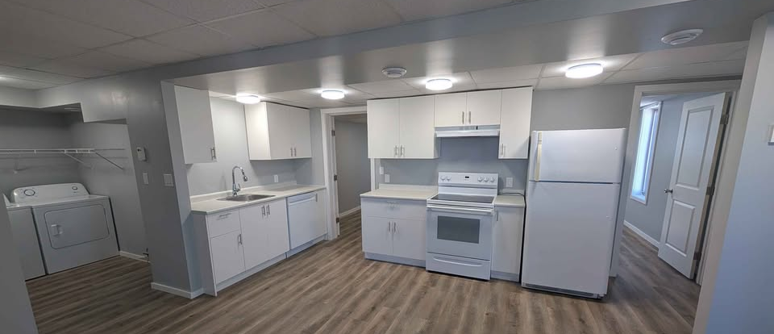
APARTMENT FOR RENT

Beautifully Renovated Country Apartment - 3 Bed 1 Bath
– Utilities Included -
Enjoy quiet country living just 1.5 miles
From Steinbach on a shared 10-acre lot.
This newly renovated 3-bedroom
Apartment offers comfortable living with:
-Hydro, water, and internet included
-In-suite laundry
-Large enclosed porch/3 season sunroom
-Recent major renovations
-Move-in ready condition
-Peaceful country setting with convenient
access to town
-Rental application required
-References required

$1,650/Month
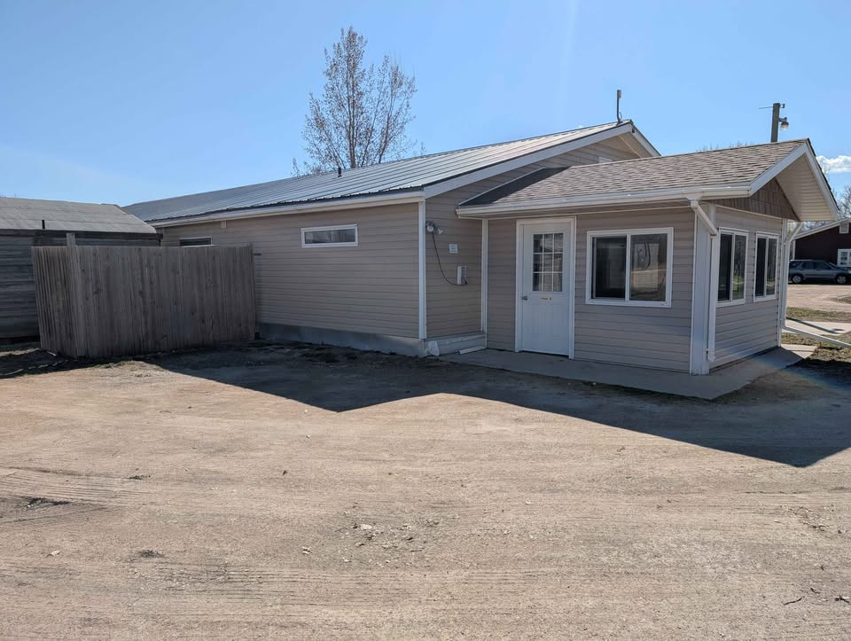
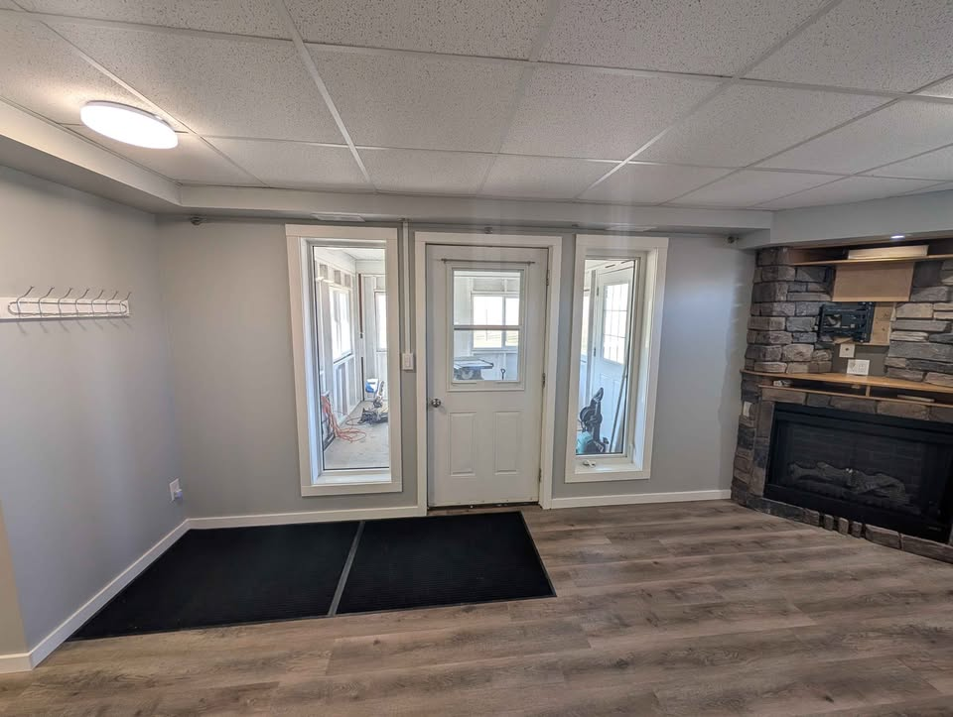
Email: harderjoe20@gmail.com

